ROYAL COURT GAME DAY

STUDENT TARGETS
- Skill: I will demonstrate striking skills with varying force and direction.
- Cognitive: I will discuss the importance of the spirit of the game with respect to enjoyment of pickleball match play.
- Fitness: I will demonstrate a variety of skill-related fitness components.
- Personal & Social Responsibility: I will demonstrate respect for myself and my classmates by following the rules of the game and encouraging others.

EQUIPMENT & SET-UP | 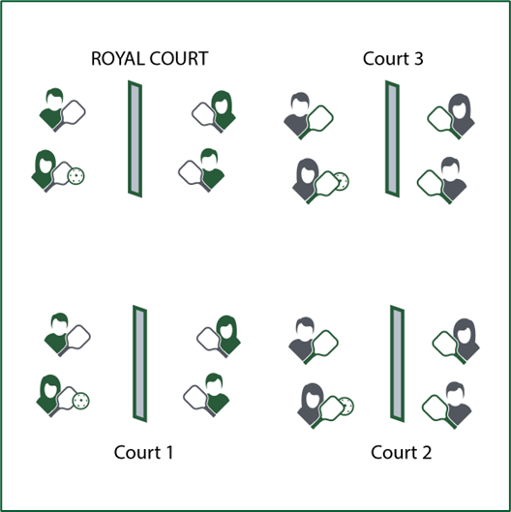
Equipment:
- 1 paddle per student
- 1 pickleball per pair of students (singles)
or per group of 4 students (doubles)
- 1 net per court (or jump ropes on ground as needed)
- Spirit of the Game Award Certificates
Set-Up:
- Create enough courts so the entire class can play in either a singles or doubles match.
- Number each court, with court 1 as the starting court and the highest numbered court as the “Royal Court.”
- Create teams for doubles, or pair students for singles play.
- Send students to courts for match play.

ACTIVITY PROCEDURES
- Today we’ll play a Royal Court Tournament as a way to test our skills and have fun with our friends. We’ll use the spirit of the game to guide our pickleball etiquette.
- The goal of today’s tournament is to compete with a positive attitude and to work your way to the Royal Court. We’ll play 3-minute games. The winner of each game will move to a higher court. The losing team or player will move down to a lower court.
- We’ll continue game play until class time runs out. Teams demonstrating positive attitudes and pickleball etiquette will be given Spirt of the Game Award Certificates.
TEACHING CUES
- Cue 1: Play with purpose!
- Cue 2: Follow the Spirit of the Game.
- Cue 3: Use positive and encouraging language with others.

ROYAL COURT GAME DAY (continued…)

UNIVERSAL DESIGN CONSIDERATIONS
- UDL 1: Allow students to work with additional partners to assist with communication if needed.
- UDL 2: Utilize visual demonstrations when possible.
- UDL 3: Provide modified movements or assistive technology as needed to ensure the activity is inclusive for all.
- UDL 4: Use a variety of options for the ball, that are of varying sizes, weights, and colors.
- UDL 5: Create a “recreation league” and de-emphasize tracking score. Students can choose participation in the Royal Court format or the Recreation League format.

ACADEMIC LANGUAGE
Direction, Encourage, Enjoyment, Force, Skill-Related Fitness, Spirit of the Game

PRIORITY OUTCOMES
Etiquette:
• (Grade 6) Identifies the rules and etiquette for physical activities/games and dance activities.
• (Grade 7) Demonstrates knowledge of rules and etiquette by self-officiating modified physical activities/games or following parameters to perform, create, or modify a dance.
• (Grade 8) Applies rules and etiquette by acting as an official for modified physical activities/games or creating dance routines within a given set of parameters.

DEBRIEF QUESTIONS
- DOK 1: How would you describe the spirit of the game to a new student in our school?
- DOK 2: What do you know about the spirit of the game? (Think beyond the definition.)
- DOK 3: How would you describe a game played with the spirit of the game? How would you describe a game played without it?
- DOK 4: Can we create a way to evaluate the amount of the spirit of the game in any specific competition or performance?

