TOSS 3

STUDENT TARGETS
- Skill: I will accurately toss and catch with a partner.
- Cognitive: I will identify ways to build trust with my teammates.
- Fitness: I will stay actively engaged throughout activity.
- Personal & Social Responsibility: I will demonstrate etiquette and respect in order to work cooperatively with teammates.

EQUIPMENT & SET-UP | 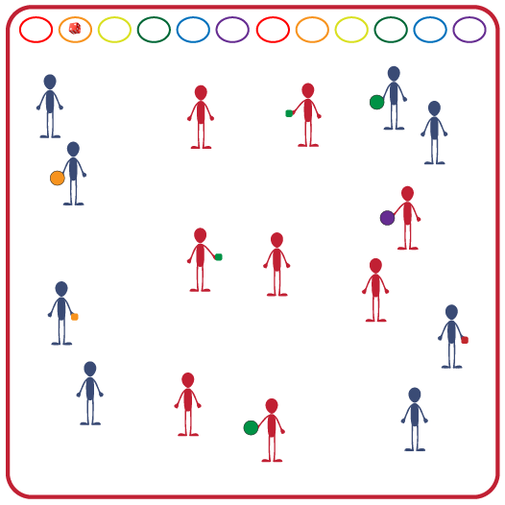
Equipment:
- 1 ball per 2 students (will need equipment options for throwing/catching, soccer, volleyball)
- 4 cones
- Music and music player

Set-Up:
- Create a large activity space using 4 cones to mark boundaries.
- Create pairs of students.
Scatter pairs of students throughout activity area. Each pair with a ball.
ACTIVITY PROCEDURES
- This Physical Health activity is called Toss 3. We are going to focus on creating open space while tossing and catching with a partner.
- The object of Toss 3 is to work with as many different classmates as you can while the music is playing. When the music starts, the partner with the ball will begin with a toss. Each pair will make 3 tosses. The partner who now has the ball will travel and find a new partner who does not have a ball.
- You continue to find a new partner after each set of 3 passes.
- We are now going to play Toss 3 using some other skills. For the next few rounds, instead of tossing and catching we will move the ball to our partner using other sport skills.
- Use Soccer passes. Can be continuous passes or you can trap the ball before passing it back.
- Use Volleyball forearm passes (bump). Can be continuous bumps or you can catch the ball before passing it back.
- You will continue to find a new partner after 3 passes or bumps.
- When the music stops be ready for the next set of instructions.

GRADE LEVEL PROGRESSION
- Grade 3: Focus on working with as many different teammates as possible.
- Grades 4 & 5: Discuss using both verbal and non-verbal communication with teammates. Play a round using only non-verbal communication.

TEACHING CUES
- Cue 1: Look at your partner to ensure they are ready before making a toss/pass: their hands are up and their eyes are looking at you.
- Cue 2: Look for both verbal and non-verbal communication from potential partners.
TOSS 3 (continued…)

UNIVERSAL DESIGN CONSIDERATIONS
- UDL 1: Increase/decrease the size of the activity space as needed.
- UDL 2: Use modified equipment as needed.
- UDL 3: Use verbal cues and visual aids, along with demonstrations.
- UDL 4: Use peer partners as appropriate.
- UDL 5: Allow teammates to hand ball off rather than passing/tossing if needed.

ACADEMIC LANGUAGE
Etiquette, Cooperation, Communication, Trust

PRIORITY OUTCOMES
Etiquette:
- (Grade 3) Recognizes the role of rules and etiquette in physical activity with peers.
- (Grade 4) Exhibits etiquette and adherence to rules in a variety of physical activities.
- (Grade 5) Critiques the etiquette involved in rules of various game activities.

DEBRIEF QUESTIONS
- DOK 1: How would you describe proper etiquette in physical education class?
- DOK 2: How does demonstrating etiquette and respect impact trust among teammates?
- DOK 3: How can having trust among teammates impact the team’s communication during games and their overall success?

