HIGH 5 BANK ACCOUNT

STUDENT TARGETS
- Skill: I will work to collect as many high fives as possible during the activity.
- Cognitive: I will discuss the importance of a warm-up to keep my body safe.
- Fitness: I will stay actively engaged during this activity.
- Personal & Social Responsibility: I will engage in responsible behaviors with my classmates and my teacher(s).

EQUIPMENT & SET-UP | 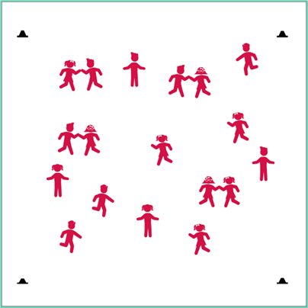
Equipment:
- 4 cones to create boundaries

Set-Up:
- Create a large activity area using 4 cones.
- Students begin spread out in the activity space.
ACTIVITY PROCEDURES
- This activity is called High 5 Bank Account. The object is to take as many high 5’s to the bank as you can during the activity.
- On the start signal, move to another classmate and give them a high-5. Then, quickly move to someone else and get another high-5.
- As soon as you collect five high-5’s, take them to the bank by doing 5 jumping jacks. You now have five high-5’s in the bank!
- Repeat this sequence as many times as you can until you hear the stop signal.
- Keep track of how many high-5’s you put in the bank. The student with the biggest bank account at the end of the activity wins!

DEBRIEF QUESTIONS
- DOK 1: What is a warm-up?
- DOK 2: Why is it important to warm-up your body before physical activity?
- DOK 3: What other fitness concepts could be addressed using this activity?
- DOK 4: How could this activity be modified to become more (or less) vigorous? How can we prove that this modification has worked?

PRIORITY OUTCOMES
Personal Responsibility & Safety:
- Grade 3: Works independently and safely in physical activity settings.
- Grade 4: Exhibits responsible behaviors in independent group situations.
- Grade 5: Engages in physical activity with responsible interpersonal behavior (e.g., peer to peer, student to teacher).

