AEROBIC TREASURE GRAB

STUDENT TARGETS
- Skill: I will move safely within the activity area by maintaining balance at a safe speed.
- Cognitive: I will discuss the importance of regular physical activity.
- Fitness: I will pace my activity so that I work within my target heart rate zone.
- Personal & Social Responsibility: I will follow the rules for Aerobic Treasure Grab without the need for teacher reminders.

EQUIPMENT & SET-UP | 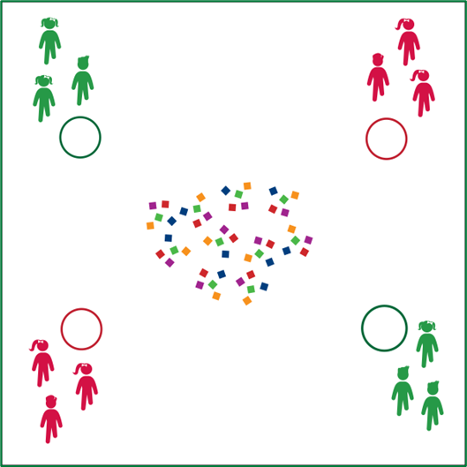
Equipment:
- 24-48 bean bags
- 1 hoop per group of 2-4 students

Set-Up:
- Use hoops to create activity boundaries and home-base areas for each team.
- Scatter bean bags in the center of the activity area.
- Create even teams of no more than 4 players per team, each team begins behind a hoop.

ACTIVITY PROCEDURES
- Today’s Plug & Play Fitness activity is called Aerobic Treasure Grab.
- The object of the activity is to collect as many bean bag treasures in your hoop as you can.
- You’ll do that in a relay-race format with 1 teammate collecting 1 bean bag at a time from the activity area. As soon as each player returns, the next player moves to collect the next bean bag. Students waiting for a turn will perform an aerobic exercise.
- Once all beanbags have been collected from the center of the activity area, teams can move to other teams’ hoops to “steal” their treasures.
- You cannot guard your hoop.
- Freeze when you hear the stop signal to receive the next set of directions.

TEACHING CUES
- Cue 1: Move safely through the activity space and be aware of surroundings.
- Cue 2: Only 1 bean bag at a time.
- Cue 3: Be sure to place the bean bags down and not toss them.

AEROBIC TREASURE GRAB (continued…)

UNIVERSAL DESIGN CONSIDERATIONS
- UDL 1: Allow students to work with additional partners to assist with communication if needed.
- UDL 2: Utilize visual demonstrations when possible.
- UDL 3: Provide modified movements or assistive technology as needed to ensure the activity is inclusive for all.
- UDL 4: Use a variety of objects as treasures, that are of varying sizes, weights, and colors.

ACADEMIC LANGUAGE
Aerobic Capacity, Actively Engage, Active Lifestyle, Sedentary Lifestyle, Vigorous

PRIORITY OUTCOMES
Etiquette:
• (Grade 3) Recognizes the role of rules and etiquette in physical activity with peers.
• (Grade 4) Exhibits etiquette and adherence to rules in a variety of physical activities.
• (Grade 5) Critiques the etiquette involved in rules of various game activities.

DEBRIEF QUESTIONS
- DOK 1: Can you remember some reasons why it’s important to be physically active every day?
- DOK 2: How would you compare and/or contrast an active lifestyle with a sedentary lifestyle?
- DOK 3: Would you consider your lifestyle active or sedentary? Can you support your choice with specific examples?

