­­

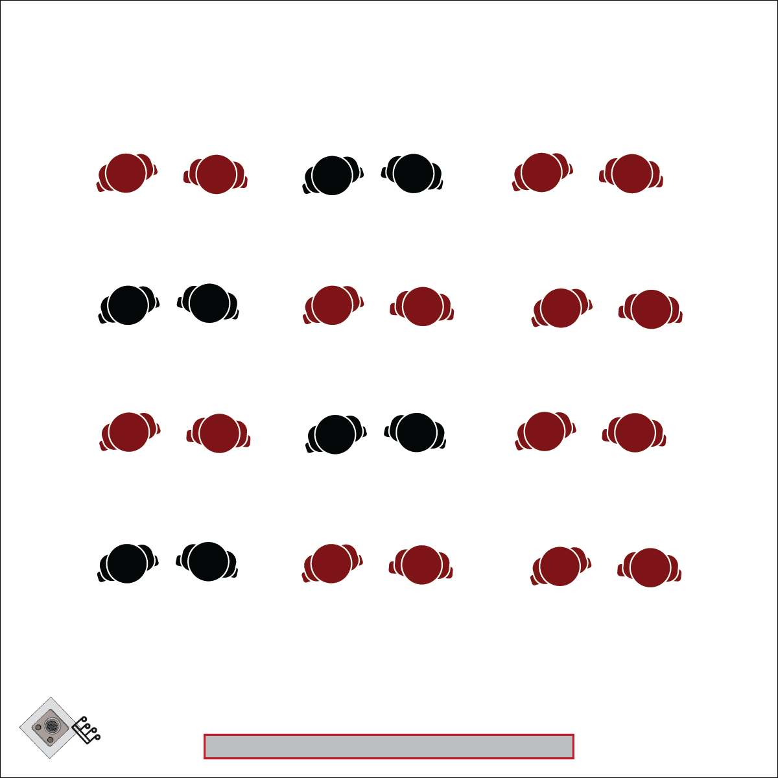

**CRAZY BIRD (BABA HOU!)**

* **Skill:** I will perform movements with the beat and tempo of music in a 1-wall or 4-wall dance.
* **Cognitive:** I will perform the order and sequence of the dance by memory.
* **Fitness:** I will increase and sustain my heart rate for the duration of the dance.
* **Personal & Social Responsibility:** I will demonstrate perseverance and share the dance space with those around me.
* Walk Forward/Backward
* Grapevine
* High Knees
* Pivot

**Equipment:**

* Music Player
* *Last Night (Baba Hou!)* ([iTunes](https://itunes.apple.com/us/album/last-night-feat-dj-robbie-best-of-dance-music/758905765))
* Crazy Bird (Baba Hou!) Activity Card
* Crazy Bird (Baba Hou!) ([Tutorial Video](https://youtu.be/If3w-G81RuE))
* Crazy Bird (Baba Hou!) ([Demonstration Video](https://youtu.be/c0wp5ZzNHpQ))

**Set-Up:**

1. Arrange students in rows, leaving enough space for students to dance without coming into contact with their neighbor.
2. Rows should be able to move forward, backward and side to side without coming into contact with any walls.

**Activity Procedures:**

1. Today’s dance is called Crazy Bird Baba Hou! This is a line dance that has a repeated sequence of 4 parts. We’ll use this dance to focus on the of the “A” element of dance: Action.
2. This dance has movements for both our lower body and our upper body. First, we’ll learn the movements for our lower body, and then learn and we’ll add on the movements for our upper body.
3. Teachers: Use the Crazy Bird Baba Hou Activity Card (and/or the video) to teach the choreography of this dance. Teach the movements without music first, and then add music.
4. The 4 parts of this dance repeat, so if you get stuck on one movement, don’t worry. Just pick up the beat on the next movement.

**Grade Level Progression:**

**6th:** Perform the activity as described above.

**7th:** Have students suggest variations to the movements.

**8th:** Have students suggest different locomotor and nonlocomotor movements to perform within the dance.

**CRAZY BIRD**



Action, Beat, Choreography, Cues, Dance, 8 Count, Grapevine, Locomotor Skills, Non-Locomotor skills, Pivot

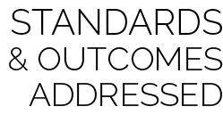

* **Standard 1 [M1.6-8]** Demonstrates correct rhythm and pattern for one of the following dance forms: folk, social, creative, line, or world dance (6); Demonstrates correct rhythm and pattern for a different dance form from among folk, social, creative, line, and world dance (7); Exhibits command of rhythm and timing by creating a movement sequence to music as an individual or in a group (8).
* **Standard 3 [M5.6-8]** Participates in a variety of lifetime recreational team sports, outdoor pursuits, or dance activities (6); Participates in a variety of lifetime dual and individual sports, martial arts, or aquatic activities (7); Participates in a self-selected lifetime sport, dance, aquatic, or outdoor activity outside of the school day (8).
* **Standard 4 [M1.6-8]** Exhibits personal responsibility by using appropriate etiquette, demonstrating respect for facilities, and exhibiting safe behaviors (6); Exhibits responsible social behaviors by cooperating with classmates, demonstrating inclusive behaviors, and supporting classmates (7); Accepts responsibility for improving one’s own levels of physical activity and fitness (8).



* **DOK 1:** What was the choreography we used to perform this dance?
* **DOK 2:** How does the sequence of the choreography affect how the dance is performed?
* **DOK 3:** How does dance enhance or detract from social settings? Does proficiency of dance performance have any effect on the social dynamics of a class or event?
* **DOK 4:** How would you change this dance to make it a better tool for connection and social collaboration?

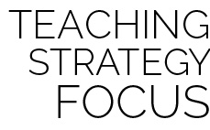

**Dance Strategy:** By middle school, almost all of your students will have some experience level with 4-wall dances. For example, they will probably know The Cupid Shuffle, The Cha Cha Slide, and/or The Wobble. Teaching them a new, complex 4-wall dance like Crazy Bird Baba Hou provides them an opportunity to expand their dance skills within a format they are familiar with; it can also progress towards physical literacy. As with all new dances, first teach them the choreography at a speed at which they can gain competence and confidence with the movements, and then slowly introduce a faster tempo and the music to accompany the movements. Feel free to adapt the existing choreography to some of your favorite movements and make this dance a favorite at your school. Dance is fun, you are awesome! Wahoo!



* Provide alternative movements for students who have different movement abilities.
* Find a song with a slower tempo or use a tempo-modifying app to slow the beat.