­­­

* Word 1
* Word 2
* Word 3
* Word 4

­

**DANCE NAME HERE**

* **Skill:** I will…
* **Cognitive:** I will…
* **Fitness:** I will…
* **Personal & Social Responsibility:** I will…
* **Standard ? [E?.3-5]** Text goes here…
* **Standard ? [E?.3-5]** Text goes here…
* **Standard ? [E?.3-5]** Text goes here…
* Dance Assessment

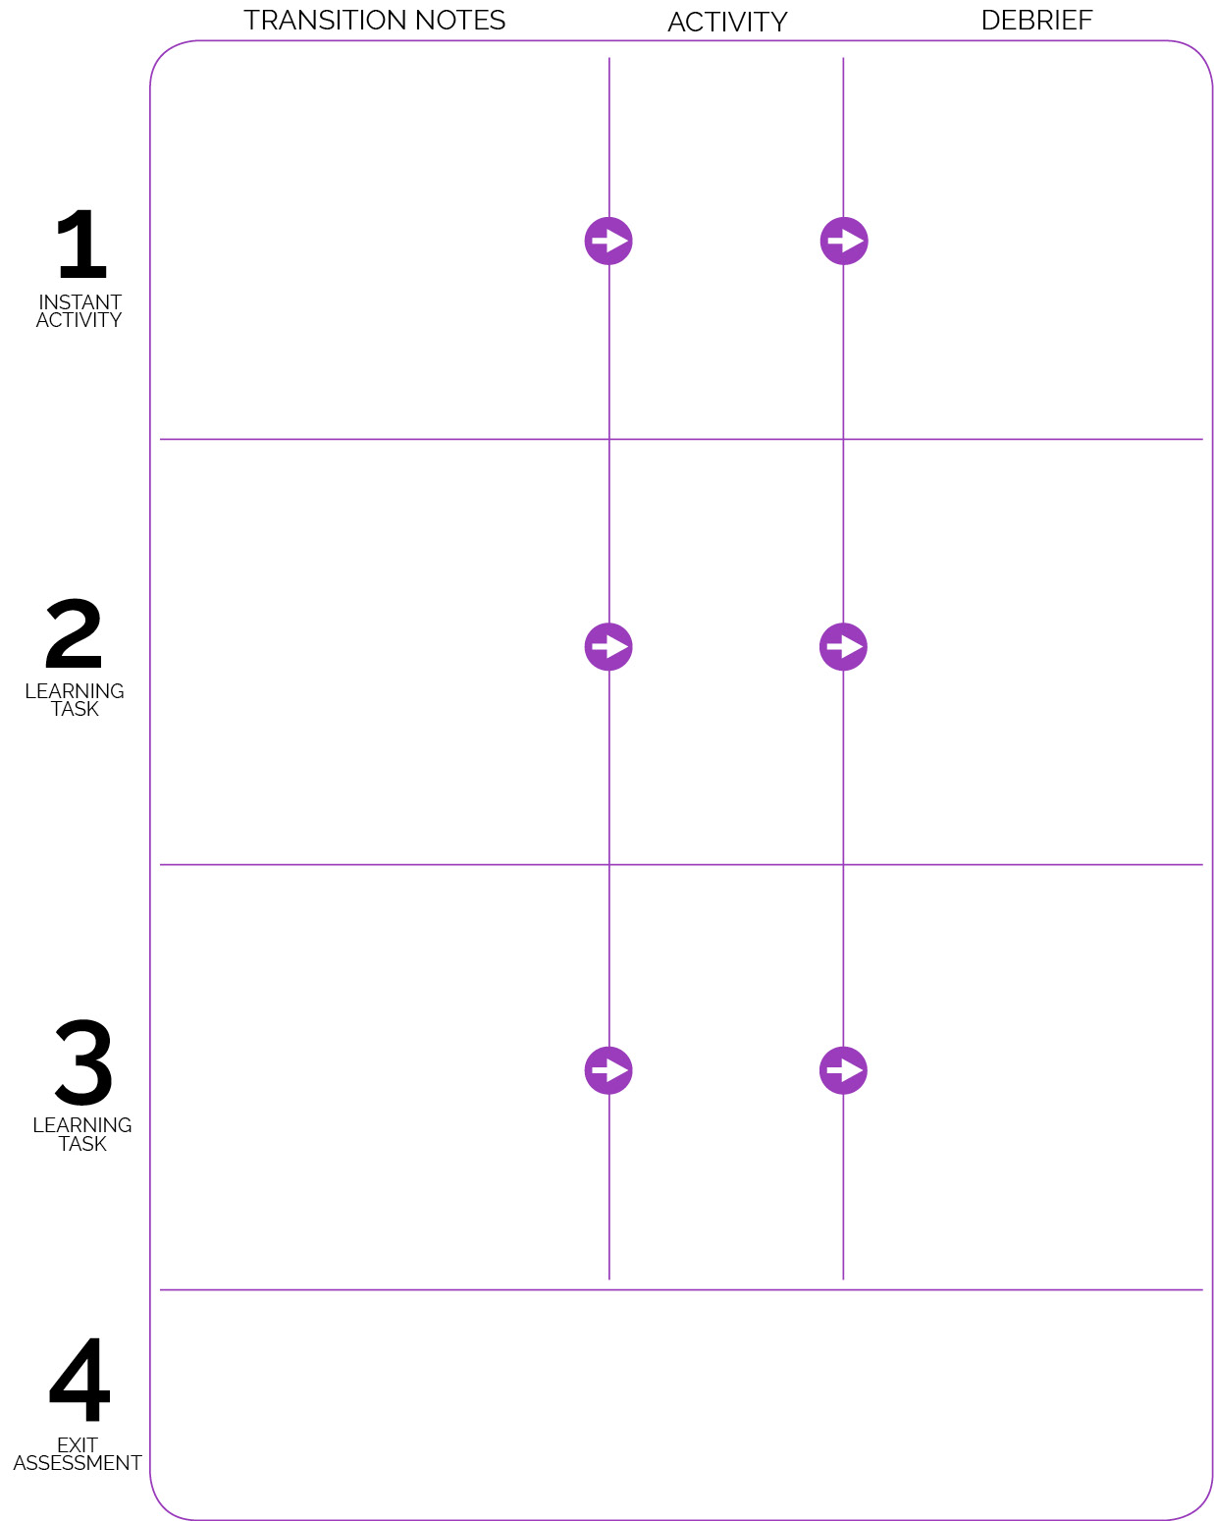

**DOK 1:** Q goes here

**DOK 2:** Q goes here

**DOK 3:** Q goes here

**DOK 1:** Q goes here

**DOK 2:** Q goes here

**DOK 3:** Q goes here

Assessment name and set-up.

Transition into activity area…

**DOK 1:** Q goes here

**DOK 2:** Q goes here

**DOK 3:** Q goes here

Transition into activity area…

Activity Name

Activity Name

Activity Name

Transition into activity area…